COVID 19 HOME PROPHYLAXIS AND DEFENCE PROTOCOL Please watch Dr. McCullough on this video: https://vimeo.com/553518199

(BASED ON THE 2021 RECOMMENDATIONS OF THE AMERICAN ASSOCIATION OF PHYSICIANS AND SURGEONS-WWW.AAPSONLINE.ORG)

BASICS:
1. COVID 19 IS NOT GOING AWAY. IT HAS MUTATED, AND MAY GET STRONGER AND MORE AGGRESSIVE.
2. YOU MUST DEFEND YOURSELF AND YOUR FAMILY/FRIENDS FROM THIS VIRUS. THE GOVERNMENT HAS NO RECOMMECNDATIONS FOR HOME HEALTHCARE FOR THIS DISEASE.
3. YOU MUST TAKE EARLY HOME-BASED MEASURES TO STOP THE INFECTION.
4. DON’T DEPEND ON THE HOSPITAL, EMERGENCY ROOOM, OR THE HOSPITAL TO DO THIS JOB. THIS IS YOUR RESPONSIBILITY.
5. THE TOOLS AND STEPS WE WILL PRESENT HAVE BEEN PROVEN BY DOCTOR’S AND PATEINTS AROUND THE GLOBE FOR THE LAST YEAR.
6. BE PROACTIVE AND GET PREPARED AS IF A DEADLY HURRICANE WAS HEADED TO YOUR HOME.
7. ALL RECOMMENDATIONS IN THIS PROTOCOL SHOULD BE REVIEWED BY YOUR DOCTOR. IF YOU ARE ALLERGIC TO ANY OF THESE DRUGS OR SUPPLEMENTS, THEN YOU NEED TO SEEK PROFESSIONAL MEDICAL ADVICE ON WHAT TO SUSTITUTE. ASK YOUR DOCTOR IF HE WILL USE THESE PROTOCOL TOOLS, AND IF NOT GET ANOTHER OPINION/CARE PROVIDER.

WHAT IS COVID-19 VIRUS PROPHYLAXIS?
Definition of prophylaxis: “A preventive measure. The word comes from the Greek for "an advance guard," an apt term for a measure taken to fend off a disease or another unwanted consequence. “

Two drugs have been proposed for this treatment plan: Hydroxychloroquine and Ivermectin. The drug chosen for this protocol is Ivermectin because of its superior and multifaceted capabilities.

Essential drugs and supplements with Dosage:

Ivermectin 0.2 mg/kg — one dose on day 1 and day 3, then take one dose weekly (recommendations range from one dose per week to once a month). Many are using a twice-a-month schedule.
(dosage calculation= divide your weight in pounds by 2.2 to get kilograms. Then multiply the kilograms by 0.2 to get your ivermectin dose in mg.)
Vitamin D3 5000 IU/day or 50000iu once a week
Liposomal Vitamin C 1000mg once a day
Quercetin 500mg/day
Zinc Sulfate 220mg/day (this should give you 50 mg of elemental zinc per day)
Adult strength aspirin (325mg tabs per day-only use with confirmed covid disease)
(one kilogram-kg- equals 2.2 pounds)

Other tools you will need:

Thermometer (infrared skin thermometers about $15 on Amazon)
Finger pulse/oximeter (about $15 on Amazon)
Table-top personal steam nebulizer ($50.00 on Amazon)
Contact your primary care doctor to see if he will treat you with these protocol drugs as a covid patient. If not, find a doctor who will! Don’t wait to the last moment. Online physicians are available.

General prophylaxis protocol:
1. Ivermectin dose orally on day one and day three. Then a single oral dose every two weeks.
2. Daily supplement dose of: liposomal vitamin C, Vitamin D3, zinc, Quercetin, and a general full-strength multivitamin,

If you are exposed to covid or start having any symptoms that look like a common cold:
1. Get a covid test. Don’t wait for the results because it could take days.
2. Immediately start a daily dose of ivermectin and keep taking a daily dose until the symptoms clear.
3. Double the dose of daily supplements. Triple the dose of Vitamins D3 and Quercetin daily.
4. Start taking doxycycline daily at 100 mg twice a day or take azithromycin at 250mg twice a day. A prescription will be needed.
5. Start measuring your temperature and oxygen saturation levels every 6 hours. Record your results and your symptoms for your doctor
6. Contact your doctor and tell him what is happening. Prepare him for more options such as monoclonal antibodies, plasma immune globulins, prednisone, aspirin, home oxygen, nebulizer treatment, etc. Ask for the doxycycline or azithromycin prescription. Ask your doctor to order home infusion of monoclonal antibodies.

If your fever goes up, your oxygen saturation drops, and/or you start having breathing difficulty:
1. Call your doctor with an update on your current status. Ask for: prednisone, inhalation therapy, immune covid globulins, monoclonal antibodies, and antivirals(favipiravir).
2. Start aspirin therapy. Ask doctor for d-dimer blood test for coagulation status. You can order this for yourself at Ultralab on the Internet ($137.00). Local blood draw at Quest.
3. Triple your daily dose of ivermectin and supplements and keep them going until resolved.
4. If breathing becomes labored, call 911.

Covid Treatment Flowchart from AAPS-2021
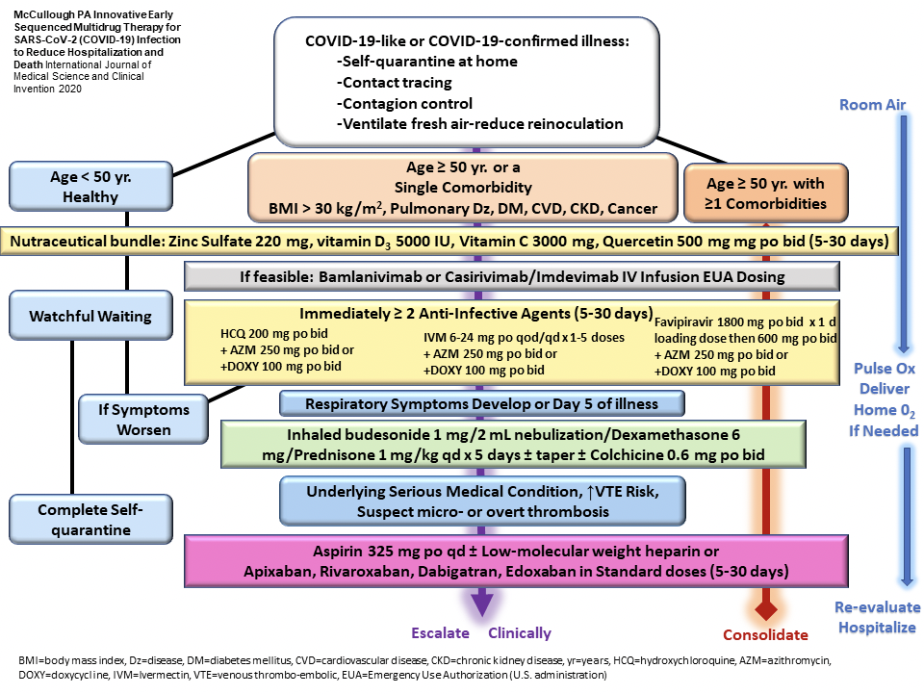
ONLINE REFERENCES FROM WWW.AAPSONLINE.ORG:
- The I-MASK+ Prophylaxis Protocol for COVID-19: https://covid19criticalcare.com/i-mask-prophylaxis-treatment-protocol/i-mask-protocol-translations/
- Zelenko Prophylaxis Protocol: https://docs.google.com/document/d/1i7C_6H1Yq0u8lrzmnzt5N1JHg-b5Hb0E3nLixedgwpQ/edit
- Indian Council of Medical Research (ICMR) – https://www.mohfw.gov.in/pdf/AdvisoryontheuseofHydroxychloroquinasprophylaxisforSARSCoV2infection.pdf
- Prophylaxis and Treatment for COVID-19 in Nursing Homes https://covexit.com/prophylaxis-and-treatment-for-covid-19-in-nursing-homes-video-highlights/

